|  |  |
| --- | --- |
| Friend No. |  |
| Member No. |  |
| Gift Aid |  |
| Anonymous |  |

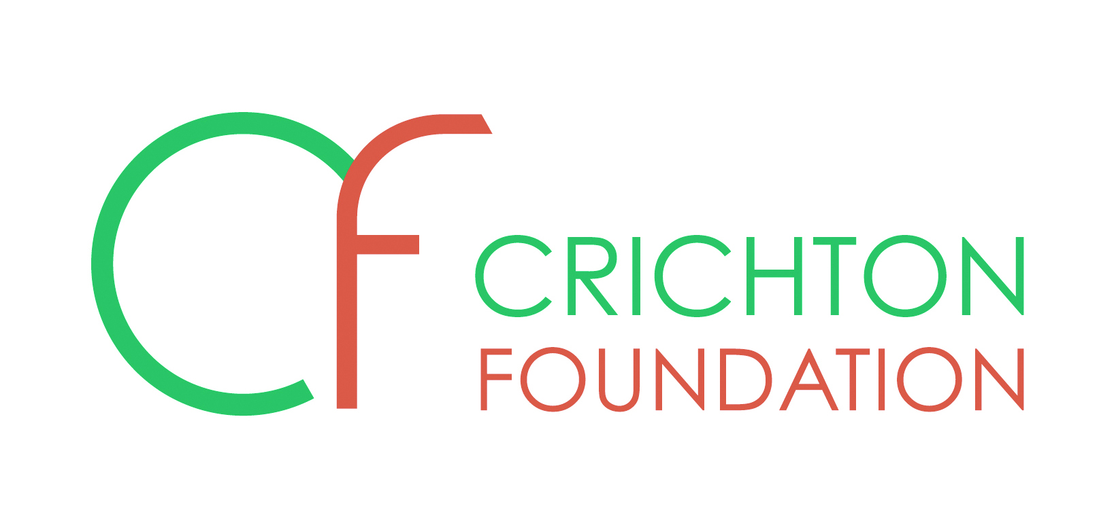

**FRIENDS SCHEME APPLICATION FORM**

|  |  |  |  |  |  |  |
| --- | --- | --- | --- | --- | --- | --- |
| **Title(s)** |  | | |  | | |
| **First name(s)** |  | | |  | | |
| **Surname(s)** |  | | |  | | |
| **Address** |  | | | | | |
|  | | | | | |
|  | | | | | |
| **Post code** |  | | | | | |
| **Tel. No.** |  | | | | | |
| **Email** |  | | | | | |
| **Signature** |  | | | | **Date** |  |
| Please enrol me as a Friend of the Foundation (please indicate which category) | | | | | | |
| **Associate: £60** per annum |  | **Individual: £120** per annum |  | | **Joint*: £210** per annum |  |
| *Joint subscriptions are for two people living at the same address | | | | | | |
| If you would like your donation to remain anonymous please tick here | | | | | |  |
| **Please return this form with your payment for the current year (cheques payable to Crichton Foundation) to:**  Crichton Foundation, Browne House, Bankend Road, Dumfries, DG1 4ZZ  Please telephone **01387 702048** or call into the office if you would like **to pay by credit or debit card** | | | | | | |
| I have enclosed a completed standing order mandate | | | | | |  |
| I prefer to pay by cheque, please send me an annual reminder | | | | | |  |

|  |  |  |  |  |  |
| --- | --- | --- | --- | --- | --- |
| For Crichton Foundation use only: | | | | | |
| NC | 4002 | Gift Aid | 30 | Non Gift Aid | 31 |
| Database |  | S/O to bank |  | Letter |  |

Scottish Charity No: SC024589 Scottish Guarantee Company No: SC361942

Registered office: Browne House, Bankend Road, Dumfries DG1 4ZZ